Image Processing Assignment 1

Tareq Kirresh 1142828

Code Snippet Used:

**pkg load image;**

**x = imread("Pepper.jpg");**

**h = imhist(x);**

**y = x(1:512,1:256,1:3)**

**z = imcomplement(y)**

**n = x;**

**n(1:512,256,1:3)=z();**

**imwrite(n,"Pepper-Negative.jpg");**

**l = imadjust(x,[],[],0.2);**

**imwrite(l,"Pepper-Gamma02.jpg");**

**l = imadjust(x,[],[],0.8);**

**imwrite(l,"Pepper-Gamma08.jpg");**

**l = imadjust(x,[],[],4.0);**

**imwrite(l,"Pepper-Gamma40.jpg");**

**Task 1 : histogram**

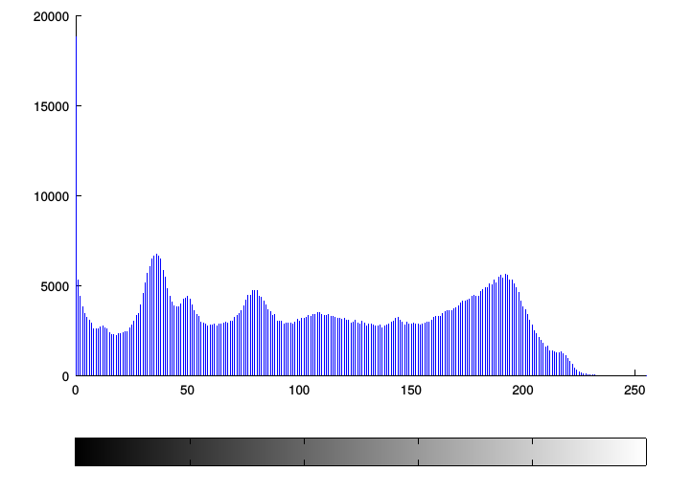

**Task 2 : Half the image negative**

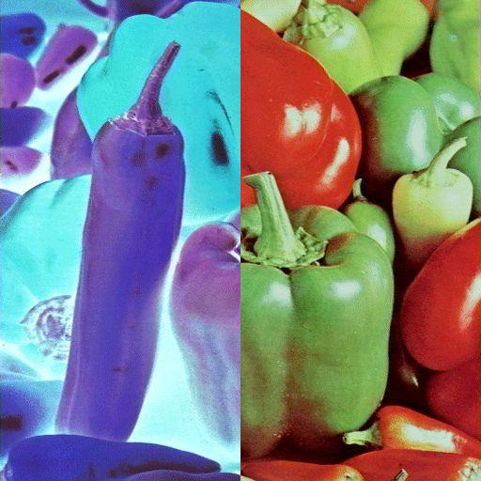

**Task 3.1 : Gamma 0.2**

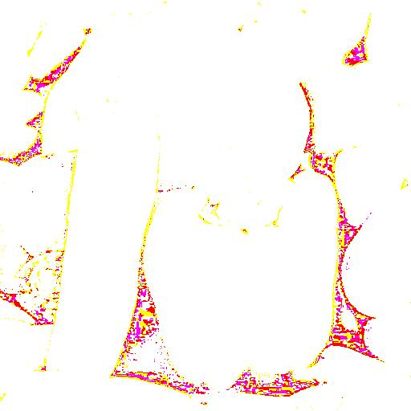

**Task 3.2 : Gamma 0.8**



**Task 3.3 : Gamma 4.0**

